Customer Requirements Specification

**Speed Bump WEB**

**ـــــــــــــــــــــــــــــــــــــــــــــــــــــــــــــــــــــــــــــــــــــــــــــــــــــــــــــــــــــــــــــــــــــــــــــــــــــــــــــــــــــــــــــــــــــــــــــــــــــــــــــــــــــــــــــــــــــــــــــــــــــــ**

**Table of Contents**

Document Status: ………………………………………………………………...1

Document History: ………………………………………………………………..1

Reference Document: …………………………………………………………....2

Project Description: ……………………………………………………………....2

# **Document Status:**

|  |  |  |
| --- | --- | --- |
| **Name** | PO_SB_CRS_WEB | |
| **Version** | V1.0 | |
| **Status** | proposed | |
| **Author** | Ahmed Mohamed | |
| **Date** | [29-10-2022] | |
| **Team approval** |  |  |
| **Mentor approval** |  |  |
| **Final approval** |  |  |

## Document History:

|  |  |  |  |
| --- | --- | --- | --- |
| **Version** | **Author** | **Date** | **Change** |
| 1.0 | Ahmed Mohamed | [29-10-2022] | Initial Creation |

|  |  |  |  |
| --- | --- | --- | --- |
| 1.1 | Ahmed Mohamed | [14-11-2022] | CRS_REV_001,  CRS_REV_002,  CRS_REV_003,  CRS_REV_004,  CRS_REV_005,  CRS_REV_006,  CRS_REV_007,  CRS_REV_008,  CRS_REV_009,  CRS_REV_010 |

### Reference Document:

|  |  |  |  |
| --- | --- | --- | --- |
| **Ref.number** | **Doc.Name** | **Version** | **Status** |
| 1 | PO_SB_CR_WEB | V1.3 | Released |

#### Project Description:

Definition:

The website for customers to purchase the speed bump detector device, and dashboard for the admin users to control the web site.

Features:

* E-commerce for a customer to buy the device.
* Dashboard for an admin to control the website.

Key Elements:

* User shall have an account.
* The E-commerce website shall show details about the product.
* Customer shall be able to place and track the order.
* Customer shall be able to send feedback.
* The website shall vary according to the user's role.
* On dashboard each admin user shall have an account.
* Dashboard shall contain page to display all users.
* Dashboard shall contain page to show keep track of stock.
* Dashboard shall contain page to show users’ feedback.

System Context:

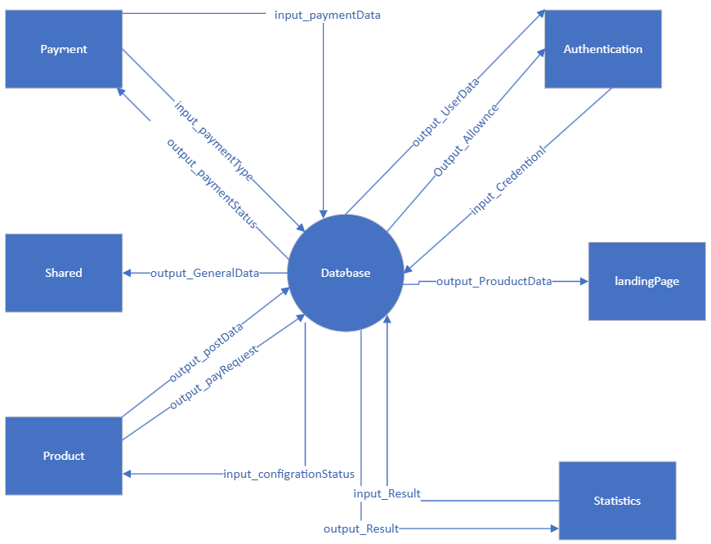

CRS Requirements:

|  |  |  |  |
| --- | --- | --- | --- |
| **Req_ID** | PO_SB_CRS_**001**-V1.0 | **Covers** | PO_SB_CR_WEB**_001**-V1.0 |
| **Description** | The user / Admin shall register on the website if he is entering for the first time. | | |

|  |  |  |  |
| --- | --- | --- | --- |
| **Req_ID** | PO_SB_CRS_**002**-V1.0 | **Covers** | PO_SB_CR_WEB**_001**-V1.0 |
| **Description** | The user/ Admin shall login if he has an account. | | |
| **Req_ID** | PO_SB_CRS_**003**-V1.0 | **Covers** | PO_SB_CR_WEB**_001**-V1.0 |
| **Description** | The user / Admin can login through Facebook. | | |
| **Req_ID** | PO_SB_CRS_**004**-V1.0 | **Covers** | PO_SB_CR_WEB**_001**-V1.0 |
| **Description** | The user / Admin can login through Google Account. | | |
| **Req_ID** | PO_SB_CRS_**005**-V1.0 | **Covers** | PO_SB_CR_WEB**_002**-V1.2 |
| **Description** | When the customer login the site, he will find a page that displays information about the device (name, description, price, customers review). | | |
| **Req_ID** | PO_SB_CRS_**006**-V1.0 | **Covers** | PO_SB_CR_WEB**_002**-V1.2 |
| **Description** | When a customer clicks the "purchase" button on the landing page, they are taken to the payment page. | | |
| **Req_ID** | PO_SB_CRS_**007**-V1.0 | **Covers** | PO_SB_CR_WEB**_003**-V1.2 |
| **Description** | Upon completion of filling in the details of the purchase (payment method, address, phone, email, name, city, postal code ,country, shipping price), after confirming the payment, the device will be reserved. | | |
| **Req_ID** | PO_SB_CRS_**008**-V1.0 | **Covers** | PO_SB_CR_WEB**_003**-V1.2 |
| **Description** | Customer can track their order, like (out for delivery , delivered , not configured) | | |
| **Req_ID** | PO_SB_CRS_**009**-V1.0 | **Covers** | PO_SB_CR_WEB**_004**-V1.0 |
| **Description** | The customer can send feedback using the form containing (email ,name ,massage). | | |
| **Req_ID** | PO_SB_CRS_**010**-V1.0 | **Covers** | PO_SB_CR_WEB**_005**-V1.3 |
| **Description** | The admin have a different rule for entering the Dashboard . | | |
| **Req_ID** | PO_SB_CRS_**011**-V1.0 | **Covers** | PO_SB_CR_WEB**_00**5-V1.3 |
| **Descripti on** | admin can control all pages like ,adding devices to the website, users page , feedback page . | | |
| **Req_ID** | PO_SB_CRS_**012**-V1.0 | **Covers** | PO_SB_CR_WEB**_006**-V1.0 |
| **Description** | dashboard admins can login to the dashboard using different email and password | | |
| **Req_ID** | PO_SB_CRS_**013**-V1.0 | **Covers** | PO_SB_CR_WEB**_007**-V1.0 |
| **Description** | The dashboard contains a page to display all users (name, email ,phone ,device id) using the mobile application and/or device. | | |
| **Req_ID** | PO_SB_CRS_**014**-V1.0 | **Covers** | PO_SB_CR_WEB**_00**8-V1.2 |
| **Description** | The dashboard contains a page to display information about all devices sold and their users like customer(name , email ,phone) , device id. | | |
| **Req_ID** | PO_SB_CRS_**015**-V1.0 | **Covers** | PO_SB_CR_WEB**_00**8-V1.2 |
| **Description** | The dashboard should contain a page to show the information of all the devices available for sale (device name , price , device id, device Bluetooth ). | | |
| **Req_ID** | PO_SB_CRS_**016**-V1.0 | **Covers** | PO_SB_CR_WEB**_0**09-V1.0 |
| **Description** | Dashboard shall contain page to show users’ feedback like (name ,email , message), and he can answer them. | | |